Repository: <https://github.com/farischaudhry/heroku-demo>

# Toy Data Set, Model Training, Flask Code (**From Week 4)**

Diabetes data set (<https://scikit-learn.org/stable/datasets/toy_dataset.html>)

442 samples; 10 features (described below) along with target value.

Features are scaled by mean and std deviation; no null entries or wrong data.

Standard training parameters used.

70% used as training data, 30% as testing data.

Model saved using pickle.

Saved as ‘model.pkl’

app.py (scale factors are from the MEANS approach above)

Port restriction had to be removed in app.run().

Index.html and style.css modified from <https://www.w3docs.com/learn-html/html-form-templates.html> (free to copy and use)

CSS: <https://github.com/farischaudhry/heroku-demo/blob/master/static/css/style.css>

HTML: <https://github.com/farischaudhry/heroku-demo/blob/master/templates/index.html>

# Heroku Deployment

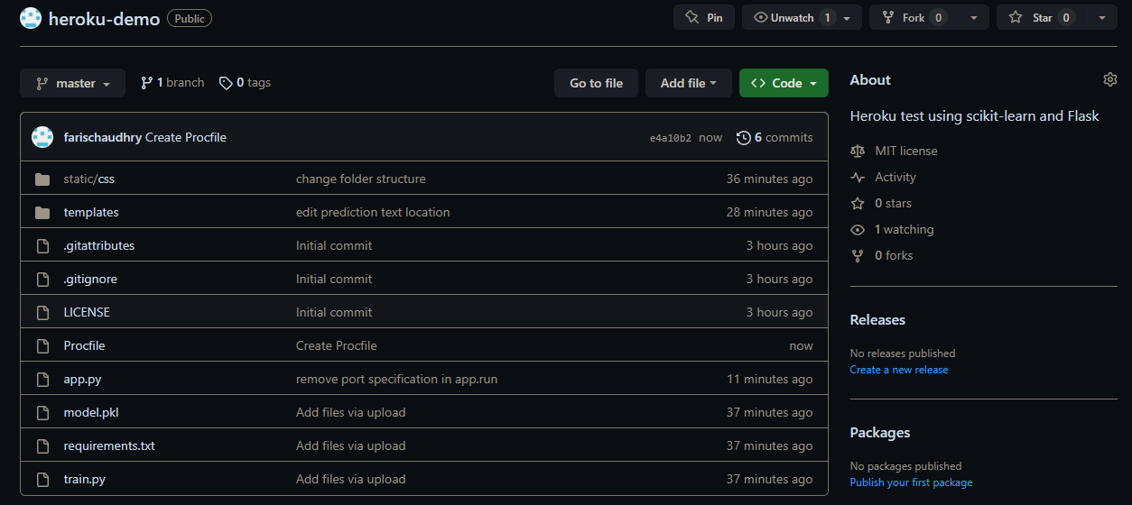

# Final Site

